**PREDICTING LIFE EXPECTANCY USING MACHINE LEARNING**

**By**

**MAHITHA KOTHAPALLY**

**CONTENTS**

1. **INTRODUCTION** 
   1. Overview
   2. Purpose
2. **EXISTING SYSTEM**
3. **PROPOSED SYSTEM**
4. **FLOWCHART**
5. **PROJECT REQUIREMENTS** 
   1. Functional Requirements
   2. Technical Requirements
   3. Software Requirements
6. **EXPERIMENTAL INVESTIGATIONS**
7. **RESULT**
8. **ADVANTAGES AND DISADVANTAGES**
9. **APPLICATIONS**
10. **CONCLUSION**
11. **FUTURE SCOPE**

**BIBILOGRAPHY**

**APPENDIX**

**1.INTRODUCTION**

* 1. **Overview**

Life expectancy refers to the number of years a person is expected to live based on the statistical average. Life expectancy varies by geographical area and by era. In mathematical terms, life expectancy refers to the expected number of years remaining for an individual at any given age. The life expectancy for a particular person or population group depends on several variables such as their lifestyle, access to healthcare, diet, economical status and the relevant mortality and morbidity data. However, as life expectancy is calculated based on averages, a person may live for many years more or less than expected.

**1.2. Purpose**

Life expectancy is perhaps the most important measure of health. Life expectancy increases due to healthcare improvements like the introduction of vaccines, the development of drugs or positive behaviour changes like the reduction in smoking or drinking rates.

**2. EXISTING SYSTEM**

As a result of the evolution of biotechnologies and related technologies such as the development of sophisticated medical equipment, humans are able to enjoy longer life expectancies than previously before. Predicting a human’s life expectancy has been a long-term question to mankind. Many calculations and research have been done to create an equation despite it being impractical to simplify these variables into one equation.

Currently there are various smart devices and applications such as smartphone apps and wearable devices that provide wellness and fitness tracking. Some apps provide health related data such as sleep monitoring, heart-rate measuring, and calorie expenditure collected and processed by the devices and servers in the cloud. However, no existing work provide the Personalized Life expectancy.

**3. PROPOSED SYSTEM**

Predicting life expectancy comes under supervised machine learning task. The project tries to build a model based on the given dataset. First, we need to deal with null values. We need to find the categorical values and convert them into numerical values. We need to split the data into training and test sets. Two types of regressions are used to predict the life expectancy, they are Random forest regression and ridge regression. Random forest regression gives more accuracy when compared to ridge regression i.e. 96%.

**4. FLOW CHART**

Start

Input values

Generates token and gain access to Watson studio

Gets the token and gain access to machine learning model

Input values are passed to ML model

Prediction done using the trained ML model

Transfer predicted value

Display output

Stop

**5. PROJECT REQUIREMENTS**

**5.1 Functional requirements**

Predict the life expectancy by creating a machine learning model

**5.2 Technical requirements**

Processors: Intel Atom® processor or Intel® Core™ i3 processor.

Input device (mouse / trackpad) to select options

32 – 64 bit processor

Sufficient RAM to run the program

**5.3 Software requirements**

Python IDE

IBM Watson studio

IBM Machine learning Instance

**6. EXPERIMENTAL INVESTIGATIONS**

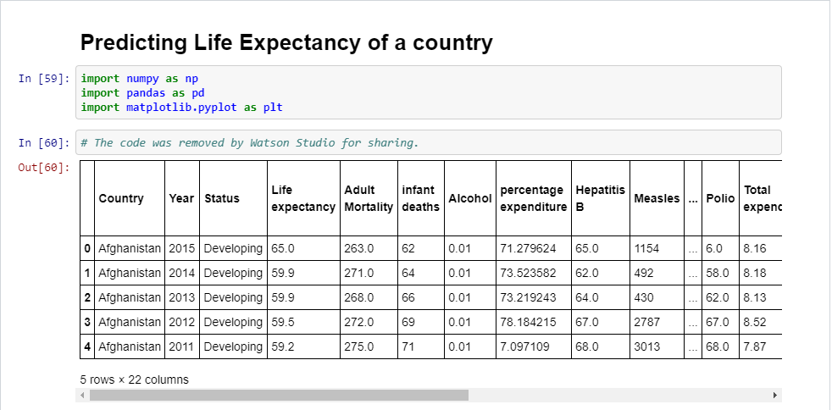

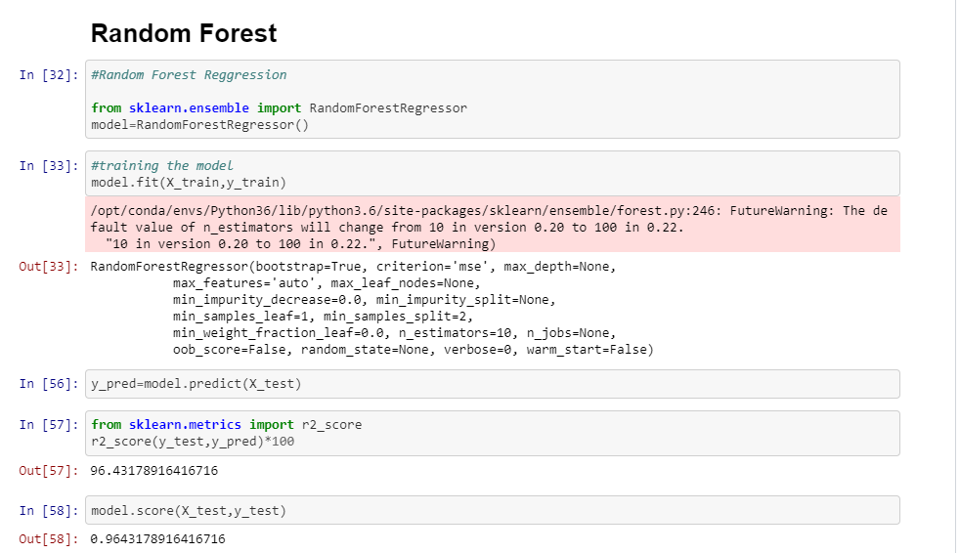

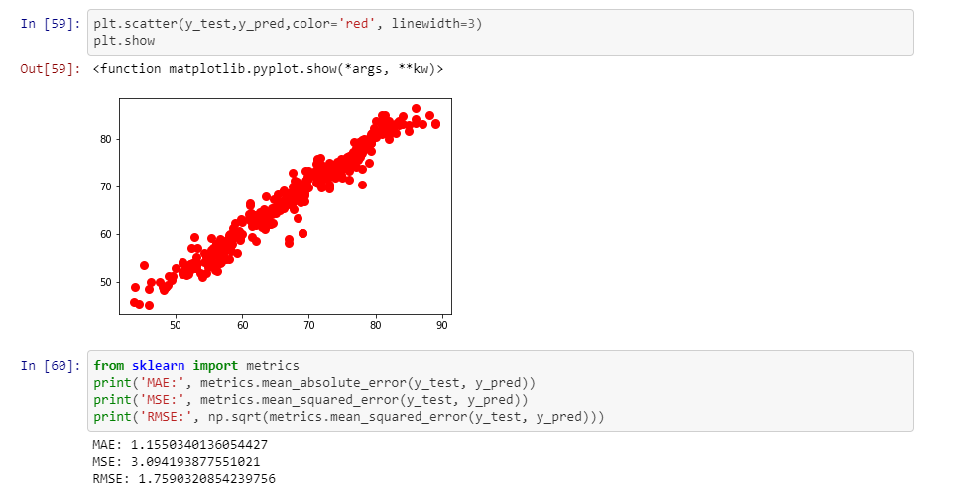

**7. RESULT**

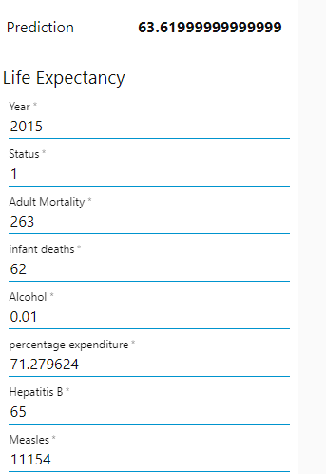

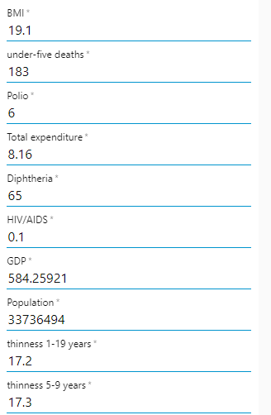

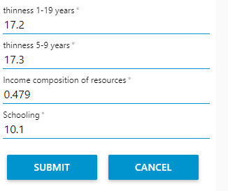

**8. ADVANTAGES AND DISADVANTAGES**

**Advantages:**

Life expectancy can be estimated at any age, e.g. life expectancy at 65 years. Gives more weight to deaths at younger ages. Life expectancy has been used nationally to monitor health inequalities.

The application learns the patterns and trends hidden within the data without human intervention which makes predicting much simpler and easier. The more data is fed to the algorithm, the higher the accuracy of the algorithm is. It is also the key component in technologies for automation.

**Disadvantages:**

This model is developed using Machine Learning in which human involvement is very less and might cause some errors and if any error occurs it takes a lot of time for the developer to identify the root cause.

**9. APPLICATIONS**

The life expectancy is used to determine gross domestic happiness of nations which is usually published in United Nations Happiness Index which is a part of United nations development report (UNDR).

It effects the health and economic policies framed by the governments of nation which is a important necessity of the idea of welfare state. Based on the factors used to calculate life expectancy of an individual and the outcome, health care will be able to fund and provide better services to those with greater need.

Insurance sector will be able to provide individualized services to people based on the life expectancy outcomes and factors.

**10. CONCLUSION**

Machine learning techniques offer a feasible and promising approach to predicting life expectancy. The research has potential for real-life applications, such as supporting timely recognition of the right moment to start Advance Care Planning. This breakthrough can widely impact health sectors and economic sectors by improving the resources, funds and services provided to the common people. It can also increase the ease of access to the individuals.

**11.FUTURE SCOPE**

The scalability and flexibility of the application can also be improved with advancement in technology and availability of new and improved resources. Also, with the growth in Artificial Neural networks and Deep learning, one can integrate that with our existing application. With the help of Convolutional Neural networks and Computer vision, we can also try to take into account the physical health and appearance of a person. Mental health can also be taken into account while predicting life expectancy with the help of sentiment analysis systems as well.

**BIBLIOGRAPHY**

* <https://www.kaggle.com/kumarajarshi/life-expectancy-who>
* <https://en.wikipedia.org/wiki/Life_expectancy>
* <https://www.youtube.com/watch?v=LOCkV-mENq8&feature=youtu.be>
* <https://www.ibm.com/cloud/get-started>
* <https://www.w3schools.com/howto/howto_make_a_website.asp>
* <https://developer.ibm.com/technologies/machine-learning/series/learning-path-machine-learning-for-developers/>
* <https://developer.ibm.com/technologies/machine-learning/series/learning-path-machine-learning-for-developers/>

**APPENDIX**

**Watson Assistant:**

Watson Assistant is a conversation AI platform that helps you provide customers fast, straightforward and accurate answers to their questions, across any application, device or channel.

**Watson Studio:**

Analysts prepare data and build models at scale across any cloud. Build models using images with IBM Watson Visual Recognition and texts with IBM Watson Natural Language Classifier. Deploy and run models through one-click integration with IBM Watson Machine Learning.

**IBM Cloud:**

IBM Cloud provides a full-stack, public cloud platform with a variety of offerings in the catalog, including compute, storage, and networking options, end-to-end developer solutions for app development, testing and deployment, security management services, traditional and open-source databases.

**Node-RED:**

Node-RED is a flow-based development tool for visual programming developed originally by IBM for wiring together hardware devices, APIs and online services as part of the Internet of Things. Node-RED provides a web browser-based flow editor, which can be used to create JavaScript functions.

**SOURCE CODE**

<https://github.com/SmartPracticeschool/llSPS-INT-1731-Predicting-Life-Expectancy-using-Machine-Learning>